SURVEILLANCE SYSTEM

Function: | Prepared by: | Reviewed by: | Approved by:
Department: | Quality Assurance | Systems and cybersecurity | Quality Assurance
Name: | Ivan Perez | David Pozo | Fernando Pozo
Signature:
Date:

Valid until: | 05/07/2028

DOCUMENT HISTORY
VERSION | CAUSES OF MODIFICATION | EFFECTIVE DATE | REPLACES (CODE, REVISION)
01 | Initial edition | 22/02/2024 | N/A
02 | Update of the procedure to align with the MEDEV guide MEDDEV 2.12-1 rev 8, according to AC-035/24 | 03/28/2024 | PNT025.01
03 | Update of SPIKA departments, modification of points 5.2.6 and 5.2.7 to comply with the provisions of Article 87 of Regulation (EU) 2017/745 of the European Parliament and of the Council of 5 April 2017 regarding the maximum reporting periods for serious incidents. | 08/20/2024 | PNT-025.2
04 | Correction of incident notification calendar | 09/26/2024 | PNT-025.03
05 | Correction of incident notification calendar | 10/14/2024 | PNT-025.04
06 | Change in Spika's departments | 02/06/2025 | PNT-025.05
07 | Clarification of the notification process to regulatory authorities | 05/07 /2025 | PNT-025.06

Content
1. Objective 4
2. Scope 4
3. Responsibilities and Departments affected 4
4. Definitions and Acronyms 5
5. Procedure 6
5.1. Generalities 7
5.2. Role of the manufacturer and incident reporting system 7
5.2.1. Criteria for reporting incidents 8
5.2.2. Conditions for the notification of periodic summaries to the Surveillance System 8
5.2.3. Circumstances that do not require notification to the system. 9
5.2.4. Trend Reports 9
5.2.5. Notifications of errors in use and misuse 9
5.2.6. Calendar for reporting an incident 9
5.2.7. Who should be notified 10
5.3. Managing user reports that arrive in Spika 10
5.4. Research 10
5.5. Results of investigations and follow-up 11
6. Distribution of Procedure 11
7. Annexes 12
8. Related documentation 12
9. Formation 12
Manufacturer Incident Report 13
Trend report template 18

- Aim
The purpose of this procedure is to define and establish Spika Tech's (hereinafter Spika) post-market surveillance system for the detection, evaluation, analysis, and reporting of incidents, adverse events, and/or adverse reactions related to its medical devices. This system ensures patient safety, complies with applicable regulatory requirements, and implements corrective measures when necessary.
- Scope
This procedure applies to medical devices distributed by SPIKA.
- Responsibilities and Departments Affected
The Technical Manager will be responsible for supervising the surveillance system, where his or her duties, together with the company's General Management, will be:
- They will notify the Competent National Authority of Field Safety incidents and Corrective Actions provided that the notification criteria are met.
- Investigate incidents and take necessary corrective actions
- They must keep the Notified Body informed of any issues that may affect certification and arise during the post-production phase. This will include any relevant changes generated by the surveillance system.
- Coordination of actions with the client upon notification of an incident related to the products
- Acting as an interlocutor with the client and/or health authorities when required
- Collaborate with the client or health authorities in providing relevant information about the products distributed by SPIKA
The affected departments are those indicated in the following table:

Department | Apply
 | Yeah | No
Address | ☒ | ☐
Environment | ☒ | ☐
Quality Assurance | ☒ | ☐
Systems and Cybersecurity | ☒ | ☐
Research and Development | ☒ | ☐
Marketing and Sales | ☒ | ☐
Management | ☒ | ☐

- Definitions and Acronyms
- Product deficiency : Any inadequacy of the identity, quality, durability, reliability, safety or effectiveness of a product, including malfunction, errors in use or inadequacy of information provided by the manufacturer.
- Recall: Any measure intended to prevent the further marketing of a product that is in the supply chain.
- Field Safety Corrective Action (FSCA): A Field Safety Corrective Action is an action taken by a manufacturer to reduce the risk of death or serious deterioration in health associated with the use of a medical device that has already been placed on the market. Such actions will be notified in the form of a Field Safety Notice.
- Field Safety Notice (FSN): A communication to customers and/or users issued by the Manufacturer or its representative regarding a Field Safety Corrective Action.
- Adverse event (AE): An event that is harmful to the health of a subject receiving pharmacological treatment without indicating a causal relationship with the treatment. Any malfunction, failure, or deterioration in the characteristics or functioning of a product, as well as any deficiency in the labeling or instructions for use that may or may have resulted in death or serious deterioration in the health of a patient or user.
- Adverse Reaction (ADR): Any harmful and unexpected reaction to the administered medications (regardless of the dose administered).
- Damage : physical injury or damage to the health of people or damage to property or the environment.
- Error in use : An act or omission of an act that has had a result different from that intended by the manufacturer or expected by the operator of the medical device.
- Improper use : Action or omission by the operator or user of a medical device as a result of conduct outside of what is intended by the Manufacturer in its risk control.
- Reasonably foreseeable misuse : Use of a product or system in a manner not intended by the manufacturer, but which may result from easily predictable human behavior.

- Procedure
For each product or family of Medical Devices designed and manufactured by SPIKA , a call must be made available in the event of a possible adverse event or reaction. In these cases, the Surveillance System Manager, in collaboration with the other departments as appropriate, must:
- Gather information and provide the information requested in relation to the manufacturing of the affected batches
- Will collaborate in the investigation associated with the incident
- If this is determined after the investigation, the company will manage the reconciliation of stored products and contact those customers who have the product for the appropriate management in each case.

This procedure ensures post-production surveillance and proper communication with regulatory authorities when incidents or adverse effects related to medical devices manufactured by SPIKA are detected.

  - Generalities
The Medical Device Surveillance System aims to facilitate the direct, early, and harmonized implementation of field safety corrective actions across all Member States where a specific device is used, rather than country-by-country measures.
Corrective actions include, but are not limited to: product recall; issuance of a Field Safety Notice; additional monitoring/modification of products in use; modification of a product's future design, components, or manufacturing process; modification of labeling or instructions for use.
All records generated through this procedure (initial reports, final reports, justifications for non-notification, follow-up reports, and trend analyses) will be managed in accordance with the current document and record control procedure, retained for at least 10 years, and made available to the competent authorities upon request.

  - Role of the manufacturer and incident reporting system
The Manufacturer or its Authorized Representative must submit an initial incident report to the Competent National Authority for registration and evaluation. Each initial report will result in a final report, unless the initial and final reports are merged into one.
However, not all incident reports will lead to corrective action. As a general principle, if there is any doubt about whether an incident should be reported, there should be a willingness to report rather than not. These considerations will be noted in the report, and if the manufacturer chooses not to report, they will be reflected in the manufacturer's documentation.
In the case of Spain, the AEMPS will be notified using the MFIR form included in Annex 1 of PNT014 Post-marketing monitoring or depending on the severity according to the Annexes included in the MEDDEV 2.12 Guide in its current version and/or on the AEMPS portal at the following address: https://www.aemps.gob.es/productos-sanitarios/vigilancia_productossanitarios/vigilancia-empresas/
Incidents occurring outside the EEA and Switzerland that do not require a Field Safety Corrective Action in these geographical areas will not be reported. Incidents occurring outside the EEA and Switzerland that would result in a Field Safety Corrective Action in these geographical areas must be reported as a Field Safety Corrective Action.
    - Criteria for reporting incidents
Events that meet criteria A, B and C described below are considered reportable incidents:
- The Event has occurred, that is, where the following have occurred:
- A malfunction or deterioration in the characteristics or deterioration of the product
- False positive or false negative results
- Unforeseen adverse reactions or side effects
- Interaction with other products/substances
- Product degradation/destruction (e.g., catching fire)
- Inadequate therapy
- Inaccuracy in labeling, instructions or advertising maintenance (e.g. omissions)
- The product is suspected of having contributed to the incident: To determine the link between the product and the incident, the manufacturer must take into account:
- Professional opinion
- Preliminary evaluation results
- Evidence of similar incidents that occurred in the past
- Any other evidence
- The event has occurred or could have resulted in one of the following situations:
- Death of a patient, user or other person
- Serious deterioration in the health status of a patient, user or other person

    - Conditions for the notification of periodic summaries to the Surveillance System
The frequency and format of the periodic reports will be agreed upon with the competent authority.
However, the following activities will be taken into account in these cases:
- Incidents described in a Field Safety Note (FSN) : Individual notifications of incidents described in FSNs are not required provided Spika has issued the relevant corrective actions. The frequency and content of these notifications will also be agreed upon with the relevant authorities.
- Common and well-documented incidents : those included in the product risk analysis, these may be exempted from reporting and may be reported in the periodic summaries.
    - Circumstances that do not require notification to the system.
These are those discovered by the user before using the product, where the event is caused by the patient's condition, because the useful life or expiration date of the medical device has been exceeded, when the protection against a failure is functioning correctly, or when foreseeable or expected side effects appear.
    - Trend Reports
Spika will be alert to potential increases or changes in the trend of product incidents and when a notable increase in incidents or a trend is observed, of:
- Reportable incidents
- Incidents exempt from mandatory notification
- Events that are not normally reportable

Notification must be made to the competent authorities, regardless of what has been agreed upon with the modality of periodic summaries that has been agreed upon.
To make trend reports, a format is included in Annex 2 , which is recommended for use in preparing trend reports.
    - Notifications of usage errors and misuse
Spika will be alerted to all reported complaints and will evaluate all potential cases of misuse and improper use. This evaluation must be based on risk management, the design of operating conditions, design validation, and corrective and preventive action procedures.
It will be noted that there are usage errors that must be reported, such as those that have resulted in death or serious deterioration of health, or that pose a serious threat to public health.
When they do not result in death or serious impairment and are due to misuse, there is no need to report it.
    - Calendar for reporting an incident
Serious incident associated with marketed products:
- It must be reported immediately after a causal relationship between the incident and the product has been established or is reasonably possible. No later than (maximum) 15 calendar days after becoming aware of the incident.
Serious threat to public health:
- It must be reported immediately, and in no case later than 2 days (calendar days) after becoming aware of the incident.
Death or serious and unforeseen deterioration of health:
- It must be reported immediately after identifying the relationship between the incident and the product (or if the relationship is suspected), and in no case later than 10 days (calendar days) after becoming aware of the incident.
Other incidents:
- They must be notified immediately after identifying the relationship between the incident and the product, and in no case later than 15 days (calendar days) after having become aware of the incident.

    - Who should be notified
Serious incident notifications must be sent to the National Competent Authority of the country where the incident occurred. In Spain, this involves notifying the Spanish Agency for Medicines and Medical Devices (AEMPS) using the appropriate form, as detailed in Regulation (EU) 2017/745.
  - Managing user reports that arrive at Spika
Spika may receive reports from users. In these cases, they will be treated as if they had been detected by Spika. This procedure will be applied in full, and the initial incident report will be sent provided that the relevant reporting criteria are met.
If Spika considers that the criteria are not met, the justification will be sent to the Competent National Authority.
  - Research
In general, Spika will conduct the investigation into incidents, using whatever tools it deems appropriate, and the Competent Authority will monitor progress.
If Spika is unable to conduct an investigation into the incident, it must immediately notify the Competent National Authority. In this case, the Authority may intervene or initiate an independent investigation if it deems appropriate. In these cases, Spika will provide the relevant information to the authorities upon request.
Spika may require, and it is recommended, access to the product, i.e., the unit that caused the incident, both for the investigation and to determine whether the incident is genuine. Every effort will be made to obtain access to the product.
Any change in the integrity of the units must be reported to the authorities, especially if it would affect subsequent product analysis.
  - Results of investigations and follow-up
Any change in the integrity of the products involved must be reported to the competent authorities without delay, especially if it affects the subsequent analysis of the product. Once the investigation is complete, Spika will initiate all necessary measures, including consultations with the Competent National Authority and the implementation of any Field Safety Corrective Actions (FSCA).
Spika will prepare a final report containing the results of the investigation and the actions taken, ensuring compliance with the requirements set out in Article 87 of Regulation (EU) 2017/745. If the investigation exceeds the established deadline, a follow-up report will be generated.
The final report will consist of a written statement of the results of the investigation and the measures taken, which may include:
- Absence of measures
- Additional monitoring of products in use
- Preventive measures in future production
- Field Safety Corrective Action (FSCA)
The report format is included in Annex 1.
- Distribution of the Procedure
Staff members in the departments listed in Section 3 (Responsibilities and Affected Departments) must be provided with a copy of this procedure. In addition, controlled copy No. 1 will be submitted to the Archives for paper archiving.
Controlled copies to be issued:
Controlled Copy No. | Departments
1 | Archive
- Annexes
NO. / REV. | QUALIFICATION
1/01 | Incident report
2/01 | Trend Report
- Related documentation
Code | QUALIFICATION
N/A | EN ISO 13485 (4.2.3 Medical device archive)
N/A | Regulation (EU) 2017/745 on medical devices
N/A | MEDDEV Guide 2.12-1 rev.8 Vigilance
N/A | MDCG 2023-3 Questions and Answers on surveillance terms and concepts as outlined in the Regulation (EU) 2017/745 on medical devices February 2023

- Training
This version requires that the affected departments indicated in section 3 receive the training indicated below:
Mark with an X | Type of training
☒ | Theoretical (reading and understanding of the procedure)
☐ | Theoretical – Practical (If you select this option, contact the Responsible Technician)

Annex 1_VERSION_0 6

Manufacturer Incident Report
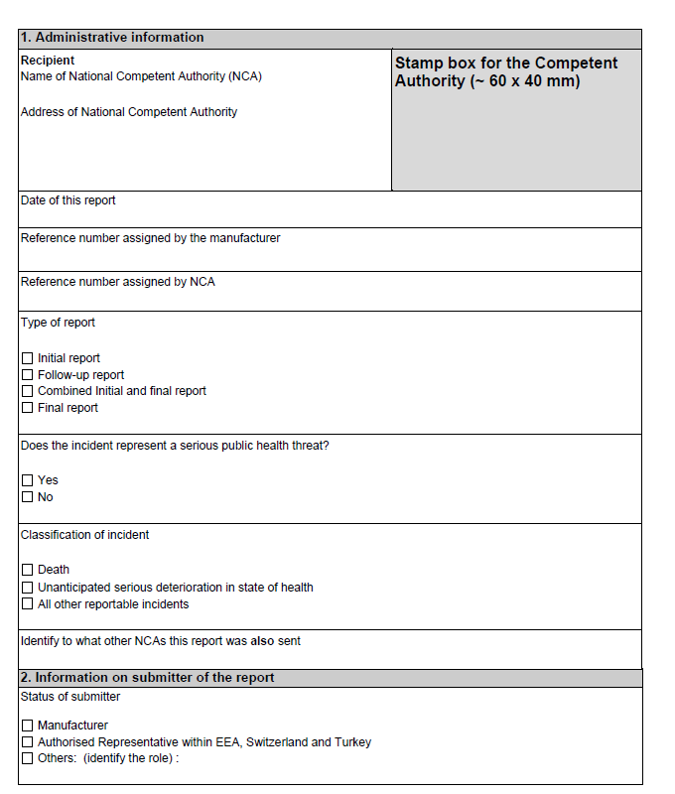

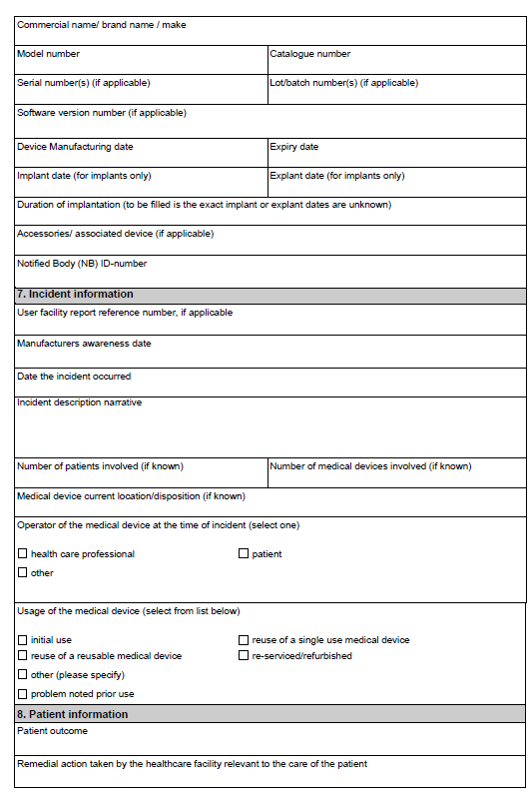

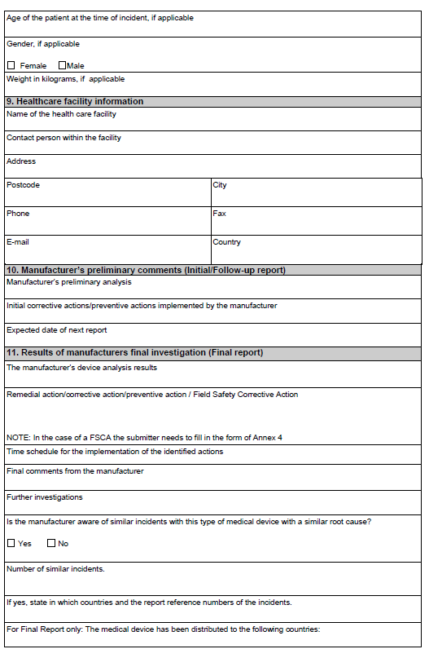

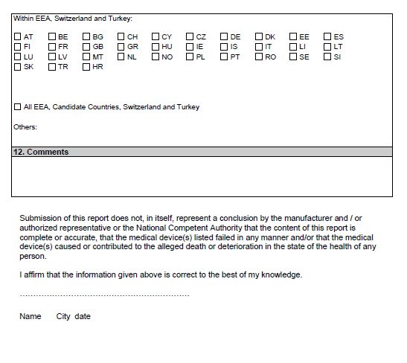

Annex 2_VERSION_06

Trend report template
